CHAPTER 4
SYSTEM DEVELOPMENT
4.1 Introduction
This chapter documents the practical development of the SentriZK secure messaging system, translating the architecture and design presented in Chapter 3 into a working software product. Where Chapter 3 described the intended methodology and high-level design, this chapter reports what was actually engineered, the tools and frameworks that were used, and the technical decisions taken during construction. The discussion follows the Rapid Application Development (RAD) lifecycle adopted for this project, in which the three core security modules — Zero-Knowledge Proof (ZKP) authentication, end-to-end encrypted (E2EE) messaging, and on-device Artificial Intelligence (AI) threat detection — were built and refined in overlapping increments.
The chapter begins by defining the development environment, frameworks, and software dependencies of each component. It then describes the installation, setup, and configuration of the backend server, the cryptographic circuits, the web portal, the mobile application, and the machine-learning pipeline. The implementation of each of the three security modules is presented in detail, followed by the user-interface and experience design, the system integration that binds the components together, the source-code management and version evolution of the project, and finally the deployment environment. It should be noted that several implementation choices evolved beyond the original proposal as the prototype matured; these deviations are highlighted and justified as informed engineering decisions at the relevant points in this chapter.
4.2 Development Environment and Tools
SentriZK was developed as a single Git monorepository containing four cooperating sub-projects: a Node.js backend, a Next.js web portal, a Flutter mobile application, and a Python machine-learning pipeline. This section defines the hardware, operating systems, integrated development environments (IDEs), languages, runtimes, and the full set of third-party dependencies used to build the system.
4.2.1 Hardware and Operating System
Development was carried out primarily on a Windows 11 workstation (a Lenovo Legion laptop with a dedicated GPU and 16 GB of RAM). The dedicated GPU was used to accelerate the training of the neural-network threat-detection models, while the 16 GB of memory allowed the Android emulator, the Node.js backend, and the Next.js development server to run concurrently. A physical Android device (minimum Android 10, API level 29) was used for final verification of camera access, biometric prompts, push notifications, deep-link handling, and on-device model inference, none of which can be assessed reliably on an emulator. Table 4.1 summarises the development and test hardware.
Table 4.1: Development and Test Hardware
Unit | Role | Key Specification
Lenovo Legion laptop | Primary development & ML training | Windows 11, dedicated GPU, 16 GB RAM
Physical Android phone | On-device verification | Android 10+ (API 29+), real sensors
Server node | Backend / database host | Self-hosted Linux node, 8 GB RAM
4.2.2 Integrated Development Environments and Tooling
Visual Studio Code was used as the principal IDE for the backend, web, and machine-learning code, while Android Studio provided the Android SDK, emulator, and Gradle build toolchain required for the Flutter application. Git was used for version control throughout, with the remote repository hosted on GitHub. Supporting command-line tools included the Node.js package manager (npm), the Flutter and Dart command-line tools, the Circom compiler and the snarkjs toolchain for the zero-knowledge circuits, and ngrok for exposing the local backend to mobile devices during testing.
4.2.3 Frameworks, Languages and Runtimes
The system is polyglot by necessity, because each tier has different performance and ecosystem requirements. The backend is written in JavaScript on the Node.js runtime (version 18 or higher) using the Express 5 web framework. The web portal is written in TypeScript using Next.js 15.5.6 with React 19. The mobile application is written in Dart (SDK 3.8) using the Flutter framework. The zero-knowledge circuits are written in the Circom 2.0.0 domain-specific language and proven with the Groth16 zk-SNARK system over the BN128 elliptic curve. The machine-learning pipeline is written in Python using TensorFlow 2.20 and Keras 3.13. Table 4.2 lists the core framework of each tier.
Table 4.2: Core Framework of Each System Tier
Tier | Language | Framework / Runtime
Backend API | JavaScript | Node.js 18+, Express 5.1
Web portal | TypeScript 5 | Next.js 15.5.6, React 19.1
Mobile app | Dart 3.8 | Flutter 3.8
ZK circuits | Circom 2.0.0 | Groth16 / BN128 (snarkjs 0.7.5)
ML pipeline | Python | TensorFlow 2.20, Keras 3.13
4.2.4 Software Dependencies
Each sub-project relies on a curated set of open-source libraries. The backend depends on snarkjs for Groth16 proof verification, circomlibjs for the Poseidon hash function, the Supabase client for PostgreSQL access, the Firebase Admin SDK for push notifications and custom-token issuance, and a set of standard security middleware (express-rate-limit, jsonwebtoken, bcryptjs, cors). The principal backend dependencies are listed in Table 4.3.
Table 4.3: Principal Backend Dependencies
Package | Version | Purpose
express | 5.1.0 | HTTP/REST framework (port 6000)
snarkjs | 0.7.5 | Groth16 zk-SNARK proof verification
circomlibjs | 0.1.7 | Poseidon hash / BN128 field arithmetic
@supabase/supabase-js | 2.101.1 | Supabase PostgreSQL client
firebase-admin | 13.0.0 | FCM push, Firestore admin, custom tokens
express-rate-limit | 8.1.0 | Brute-force / rate-limit protection
jsonwebtoken | 9.0.3 | Admin session JWT (HS256)
bcryptjs | 3.0.3 | Admin password hashing
The web portal depends on snarkjs and circomlibjs to generate zero-knowledge proofs inside the browser, together with bip39 for recovery-phrase generation, js-sha3 for username hashing, crypto-js for client-side salt encryption, and axios for backend communication. Table 4.4 lists the principal web dependencies.
Table 4.4: Principal Web Portal Dependencies
Package | Version | Purpose
next / react | 15.5.6 / 19.1.0 | Web application framework
snarkjs | 0.7.5 | In-browser Groth16 proof generation
circomlibjs | 0.1.7 | Poseidon / field arithmetic
bip39 | 3.1.0 | 24-word recovery mnemonic
js-sha3 | 0.9.3 | SHA3-256 username / address hashing
crypto-js | 4.2.0 | AES salt-envelope encryption (browser)
axios | 1.12.2 | REST calls to the backend
The mobile application has the largest dependency surface because it hosts the messaging, encryption, on-device inference, calling, and notification features. Its most significant dependencies are listed in Table 4.5. Two of these choices differ from the original proposal and are discussed further in the relevant sections: the Signal Protocol implementation libsignal_protocol_dart is used for message encryption in place of a bespoke scheme, and the Isar embedded database is used for local storage in place of Hive. State management uses the lightweight provider package rather than GetX.
Table 4.5: Principal Mobile Application Dependencies
Package | Version | Purpose
libsignal_protocol_dart | 0.7.2 | Signal Protocol (X3DH + Double Ratchet) E2EE
tflite_flutter | 0.12.0 | On-device TensorFlow Lite inference
isar / isar_flutter_libs | 3.1.0 | Embedded reactive NoSQL database
flutter_secure_storage | 10.0.0 | Android Keystore / iOS Keychain storage
provider | 6.1.5 | State management (ChangeNotifier)
app_links / url_launcher | 7.0.0 / 6.3.2 | Deep-link bridge to the web portal
cloud_firestore / firebase_messaging | latest | Ciphertext relay and FCM push
flutter_webrtc | 0.12.1 | Audio / video calling (DTLS-SRTP)
cryptography | 2.5.0 | AES-256-GCM recovery-salt envelope
The machine-learning pipeline depends on TensorFlow and Keras for model construction and TensorFlow Lite conversion, scikit-learn for the train/validation split and evaluation metrics, pandas and numpy for data handling, and matplotlib with seaborn for generating the evaluation charts. The training environment also includes a CUDA-enabled build of PyTorch, which was used during experimentation.
4.3 System Architecture as Implemented
The realised system is organised into four tiers that cooperate over the network. The Flutter mobile application is the primary client used by employees for messaging and calling. A Next.js web portal acts as a dedicated cryptographic surface that performs the computationally heavy zero-knowledge proof generation that the mobile device cannot run efficiently. A Node.js/Express backend verifies proofs, manages sessions, and brokers notifications. Persistence is split between a Supabase PostgreSQL database, which stores authentication state, and Firebase Firestore, which relays encrypted messages and supports real-time features. Figure 4.1 presents the full system architecture as it was implemented.
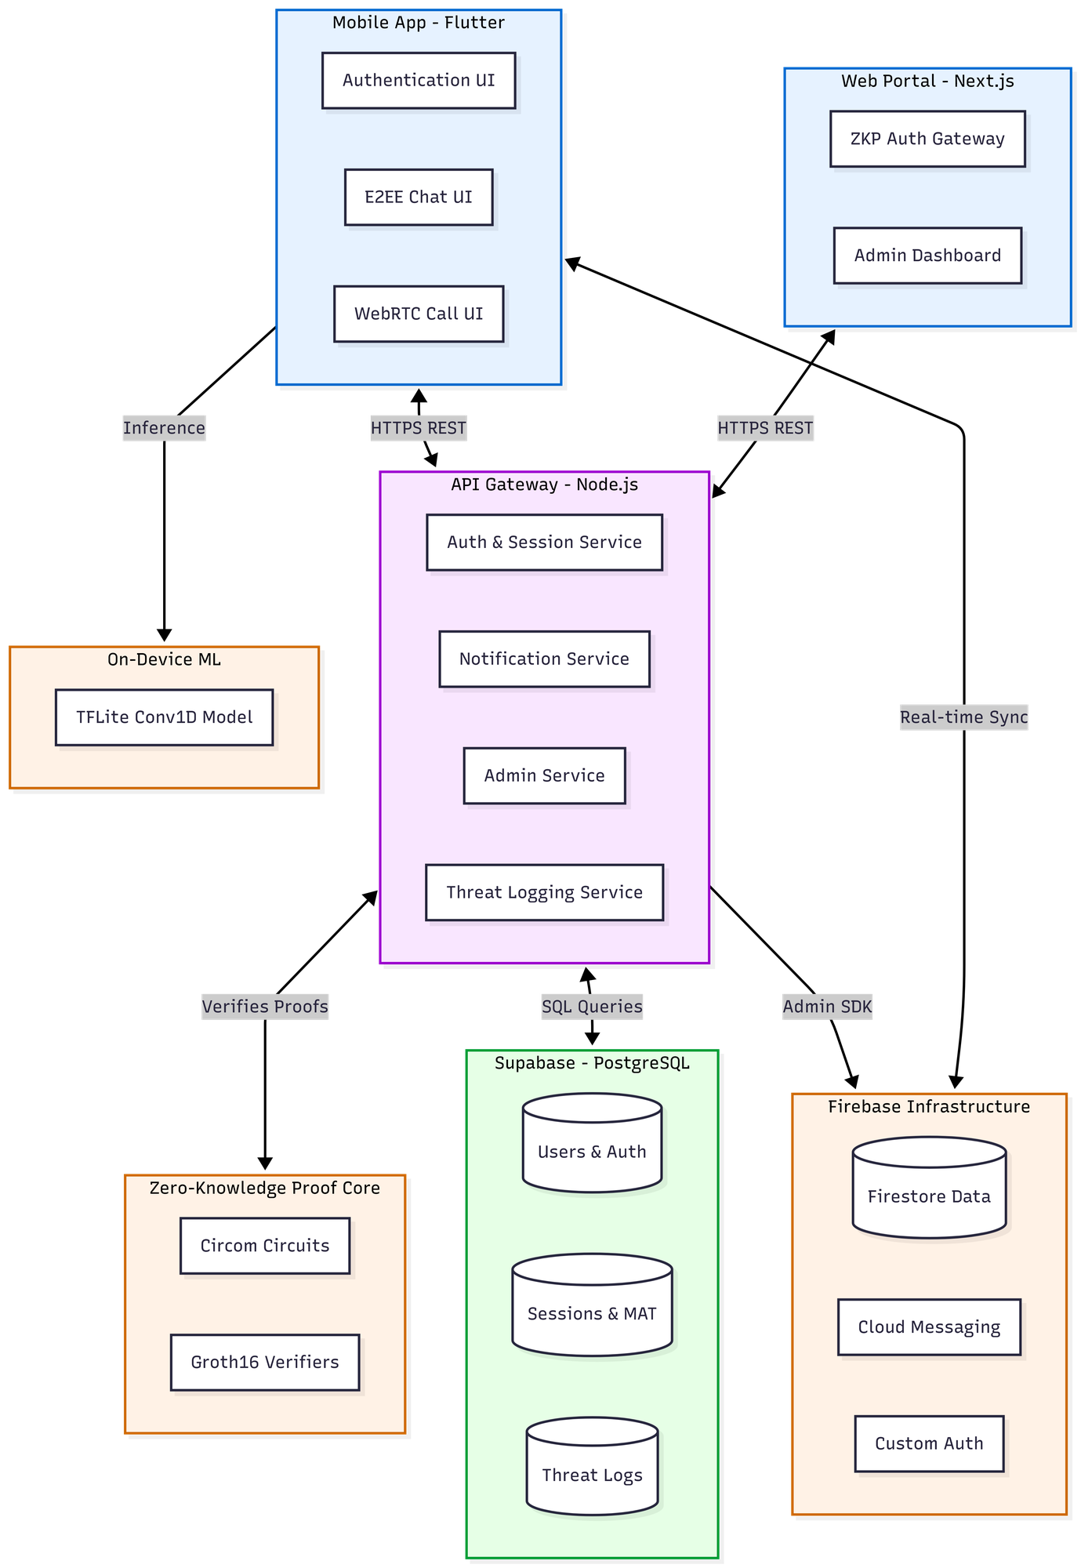
Figure 4.1: SentriZK Full System Architecture (as implemented)
A defining principle of the architecture is that the server never holds material that would be valuable to an attacker. The backend stores only Poseidon commitments rather than passwords, and the messaging tier stores only Signal Protocol ciphertext rather than plaintext. The internal structure of the mobile client — its services for authentication, messaging, encryption, scanning, and notifications — is shown in Figure 4.2.
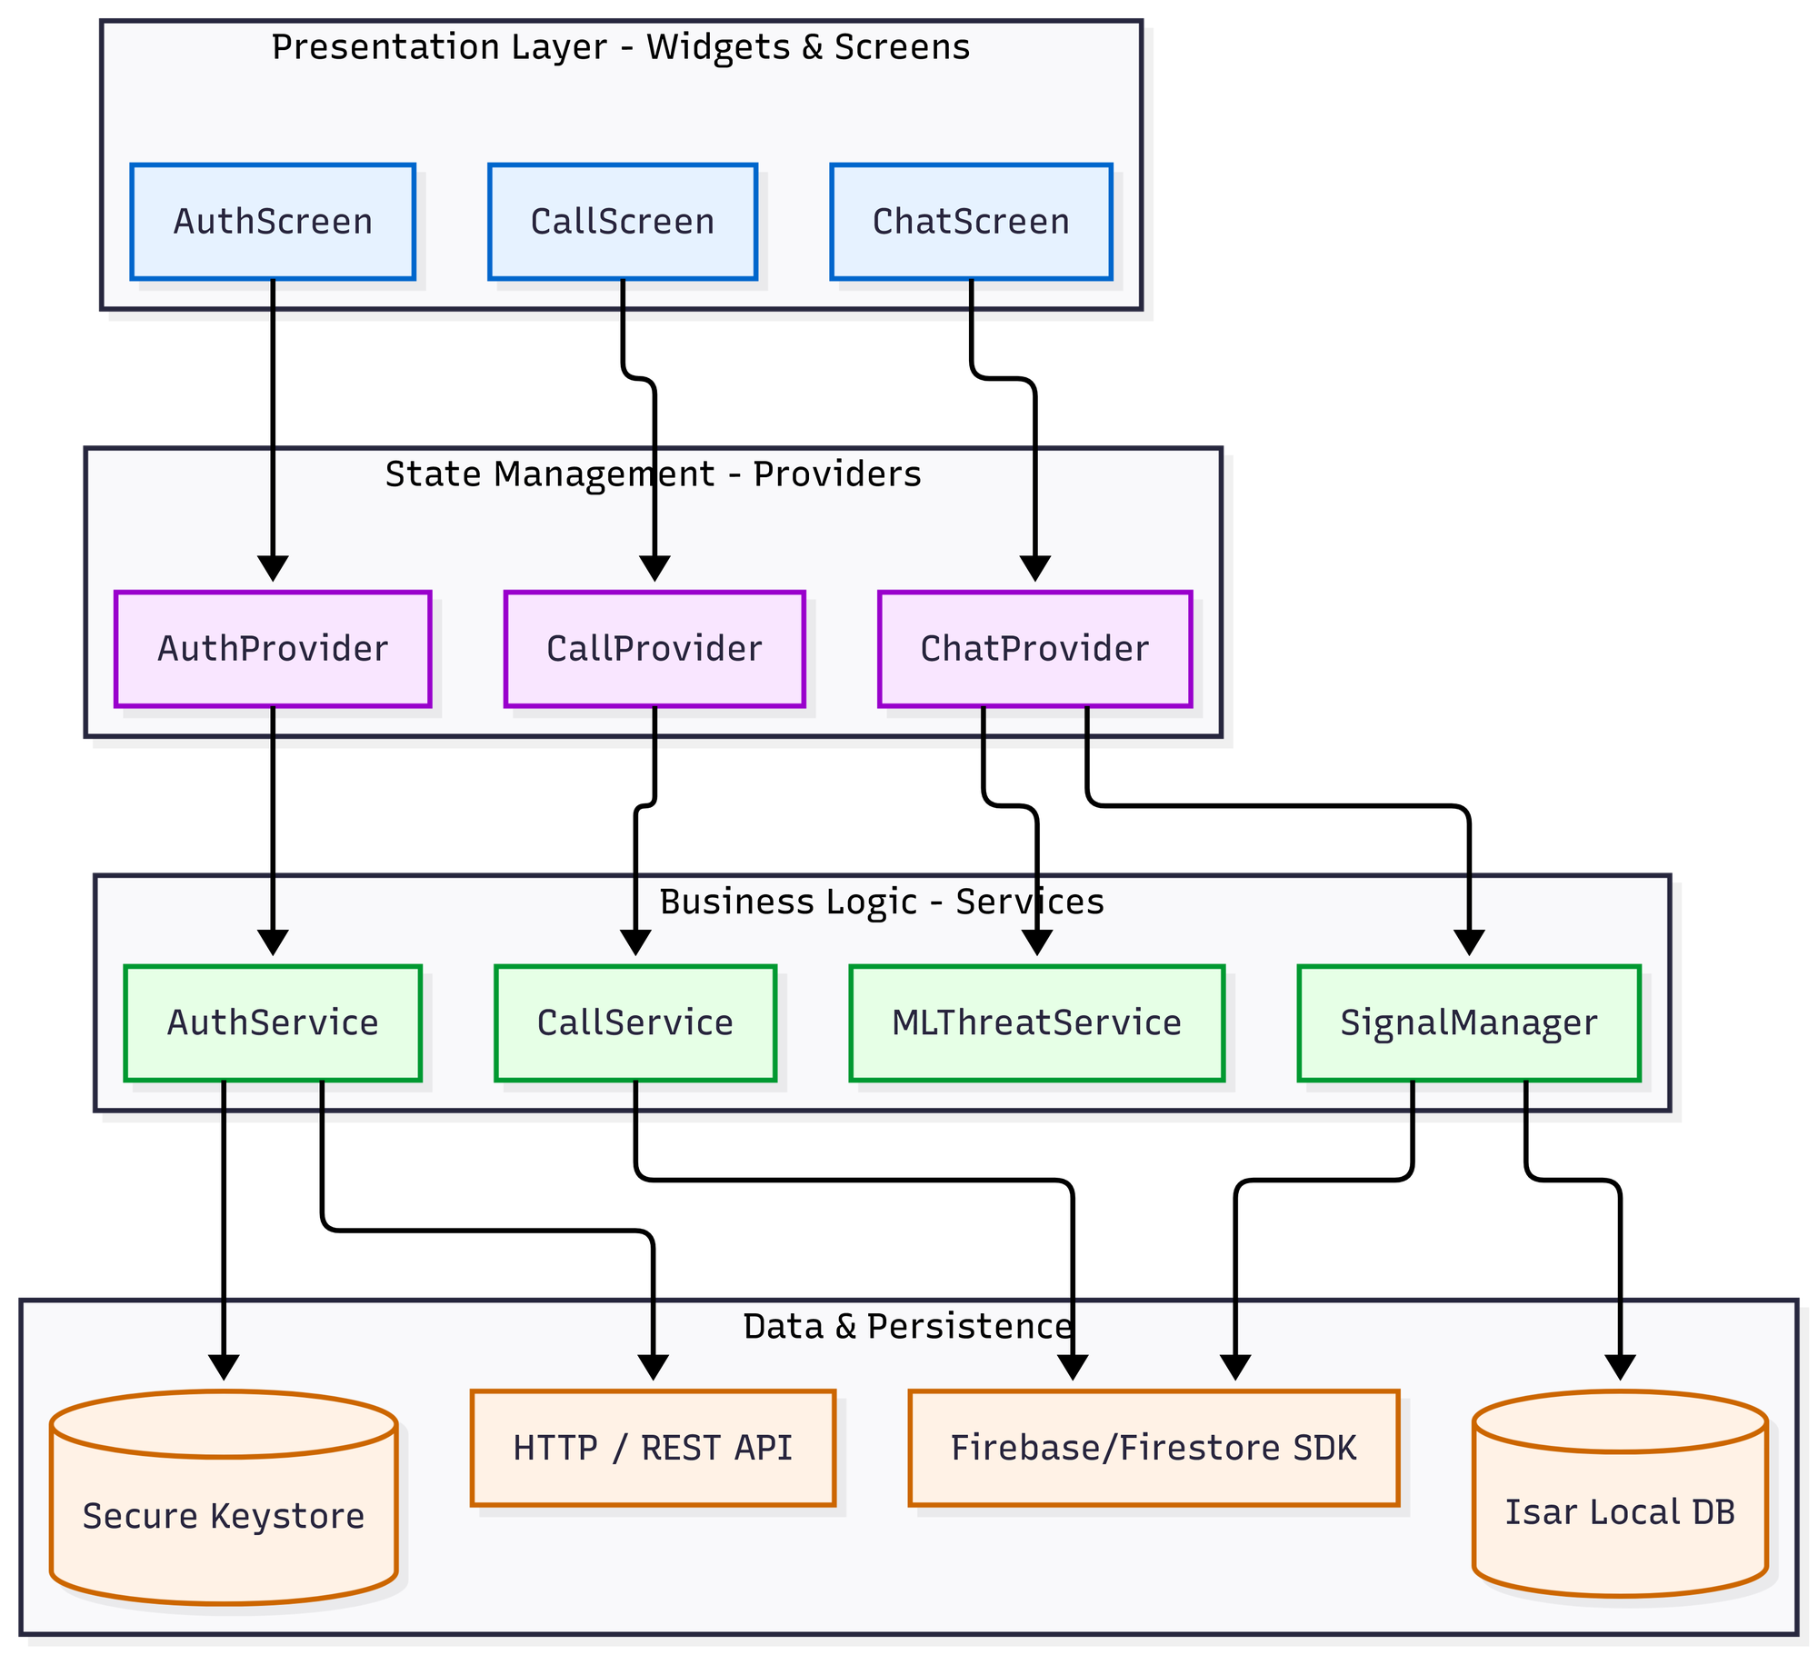
Figure 4.2: Component Diagram of the Flutter Mobile Application
4.4 Installation, Setup and Configuration
This section describes how each component is installed and configured. Configuration is centralised so that environment-specific values — service URLs, database credentials, and cryptographic artefact paths — are kept out of the source code. The backend and test tooling read configuration from .env files; the web portal reads public configuration from NEXT_PUBLIC_ environment variables; and the mobile application reads its endpoints from a single app_config.dart file with an optional .env override.
4.4.1 Backend Server Setup
The backend is installed with npm install inside the Backend directory and started with node server.js, after which it listens on port 6000 and binds to all interfaces. Before it will start, several pieces of configuration must be present. A .env file must supply the Supabase URL and service-role key, the administrator credentials, and the JWT signing secret; the server deliberately refuses to start if any of these are missing. A Firebase service-account key file must be present so that the Admin SDK can issue custom tokens and send push notifications. The two zero-knowledge verification keys must be present on disk, and the Poseidon hash function is built once at start-up; endpoints that depend on it return a temporary unavailable status until it is ready. Finally, the Supabase schema script must be applied to create the five database tables and their indexes.
Table 4.6: Backend Environment Configuration
Variable | Purpose
SUPABASE_URL / SUPABASE_SERVICE_ROLE_KEY | PostgreSQL connection (required)
ADMIN_USERNAME / ADMIN_PASSWORD | Admin dashboard credentials
JWT_SECRET / JWT_TTL | Admin JWT signing key and lifetime (default 1h)
PORT | Listening port (default 6000)
serviceAccountKey.json | Firebase Admin SDK private key (file)
4.4.2 Zero-Knowledge Circuit Compilation and Trusted Setup
The two Circom circuits are compiled with the Circom 2.0.0 compiler into a WebAssembly witness generator and an R1CS constraint system. A Groth16 trusted setup is then performed with snarkjs: a Powers-of-Tau phase produces the universal parameters, a circuit-specific phase-two contribution produces the proving key (a .zkey file), and the verification key is exported as JSON. The proving keys and WebAssembly witness generators are copied into the web portal so that proofs can be generated in the browser, while the verification keys are loaded by the backend. The compiled artefacts are compact: the registration witness generator is approximately 1.84 MB and its proving key approximately 459 KB, while the login witness generator is approximately 2.17 MB and its proving key approximately 740 KB.
4.4.3 Web Portal Setup
The web portal is installed with npm install inside the Frontend/web directory and run with npm run dev for development or built with npm run build for production, both using the Turbopack bundler. Its configuration consists of the backend API URL and the four paths to the circuit artefacts (the login and registration WebAssembly and proving-key files), which are served as static assets from the public directory. No secret values are stored in the web tier, because all sensitive cryptographic material is derived transiently on the client and never persisted.
4.4.4 Mobile Application Setup
The mobile application is installed with flutter pub get inside the Frontend/mobile directory and run with flutter run on a connected device or built for release with flutter build apk. Its endpoints are configured in a single app_config.dart file, which points the application at the backend API and the web portal and defines the custom deep-link scheme, the session and token lifetimes, and the machine-learning thresholds. Firebase is configured through the standard google-services.json file, and an optional .env file supplies the Google Safe Browsing API key.
4.4.5 Machine-Learning Pipeline Setup
The machine-learning pipeline is a self-contained Python project. After the dependencies are installed, the single training script is executed to read the prepared dataset, train the models, convert the mobile model to TensorFlow Lite, and export the vocabulary file. The two output artefacts — the quantised model and its vocabulary — are then copied into the mobile application's asset bundle, from where they are loaded at runtime.
4.5 Implementation of the Core Security Modules
The construction phase concentrated on three modules that together deliver the project's objectives: zero-knowledge authentication, end-to-end encrypted messaging, and on-device AI threat detection. Each module is presented below in terms of what was built, the specific techniques used, and, where applicable, how and why the implementation departed from the original proposal.
4.5.1 Module A: Zero-Knowledge Proof Authentication
The authentication module replaces password transmission with a zero-knowledge proof of knowledge. Two Circom 2.0.0 circuits were written. The registration circuit computes a single Poseidon commitment from the user's secret, a salt, and a hash of the username; the secret is range-checked to 256 bits and the salt to 128 bits. The login circuit recomputes that commitment from the same private inputs, asserts that it equals the commitment stored on the server, and additionally outputs a Poseidon session value that binds the proof to a fresh server-issued nonce. The two circuits compile to 991 and 1,573 rank-one constraints respectively, confirming that the proofs are small enough to generate and verify quickly. Table 4.7 summarises the circuit parameters.
Table 4.7: Zero-Knowledge Circuit Parameters
Property | Registration circuit | Login circuit
Commitment | Poseidon(secret, salt, unameHash) | recomputed and asserted equal
Private inputs | secret (256-bit), salt (128-bit) | secret, salt
Public inputs | unameHash | unameHash, storedCommitment, nonce (64-bit)
Outputs | commitment | pubCommitment, pubSession
R1CS constraints | 991 | 1,573
Proving system | Groth16 / BN128 | Groth16 / BN128
A practical constraint shaped the most significant design decision in this module. Groth16 proof generation depends on the snarkjs WebAssembly prover, which a Flutter application cannot execute efficiently on-device. Rather than weaken the cryptography, the implementation delegates proof generation to the web portal through a short-lived Mobile Access Token (MAT). When the user initiates registration or login, the mobile application requests a single-use, device-bound MAT that is valid for five minutes, then opens the system browser to the web portal carrying that token. The browser performs the heavy proof generation and submits the proof to the backend, and the result is returned to the application through a custom sentriapp:// deep link. This bridge keeps every secret on the user's own devices while moving only the computational burden to the browser. The registration and login sequences are shown in Figure 4.3 and Figure 4.4.
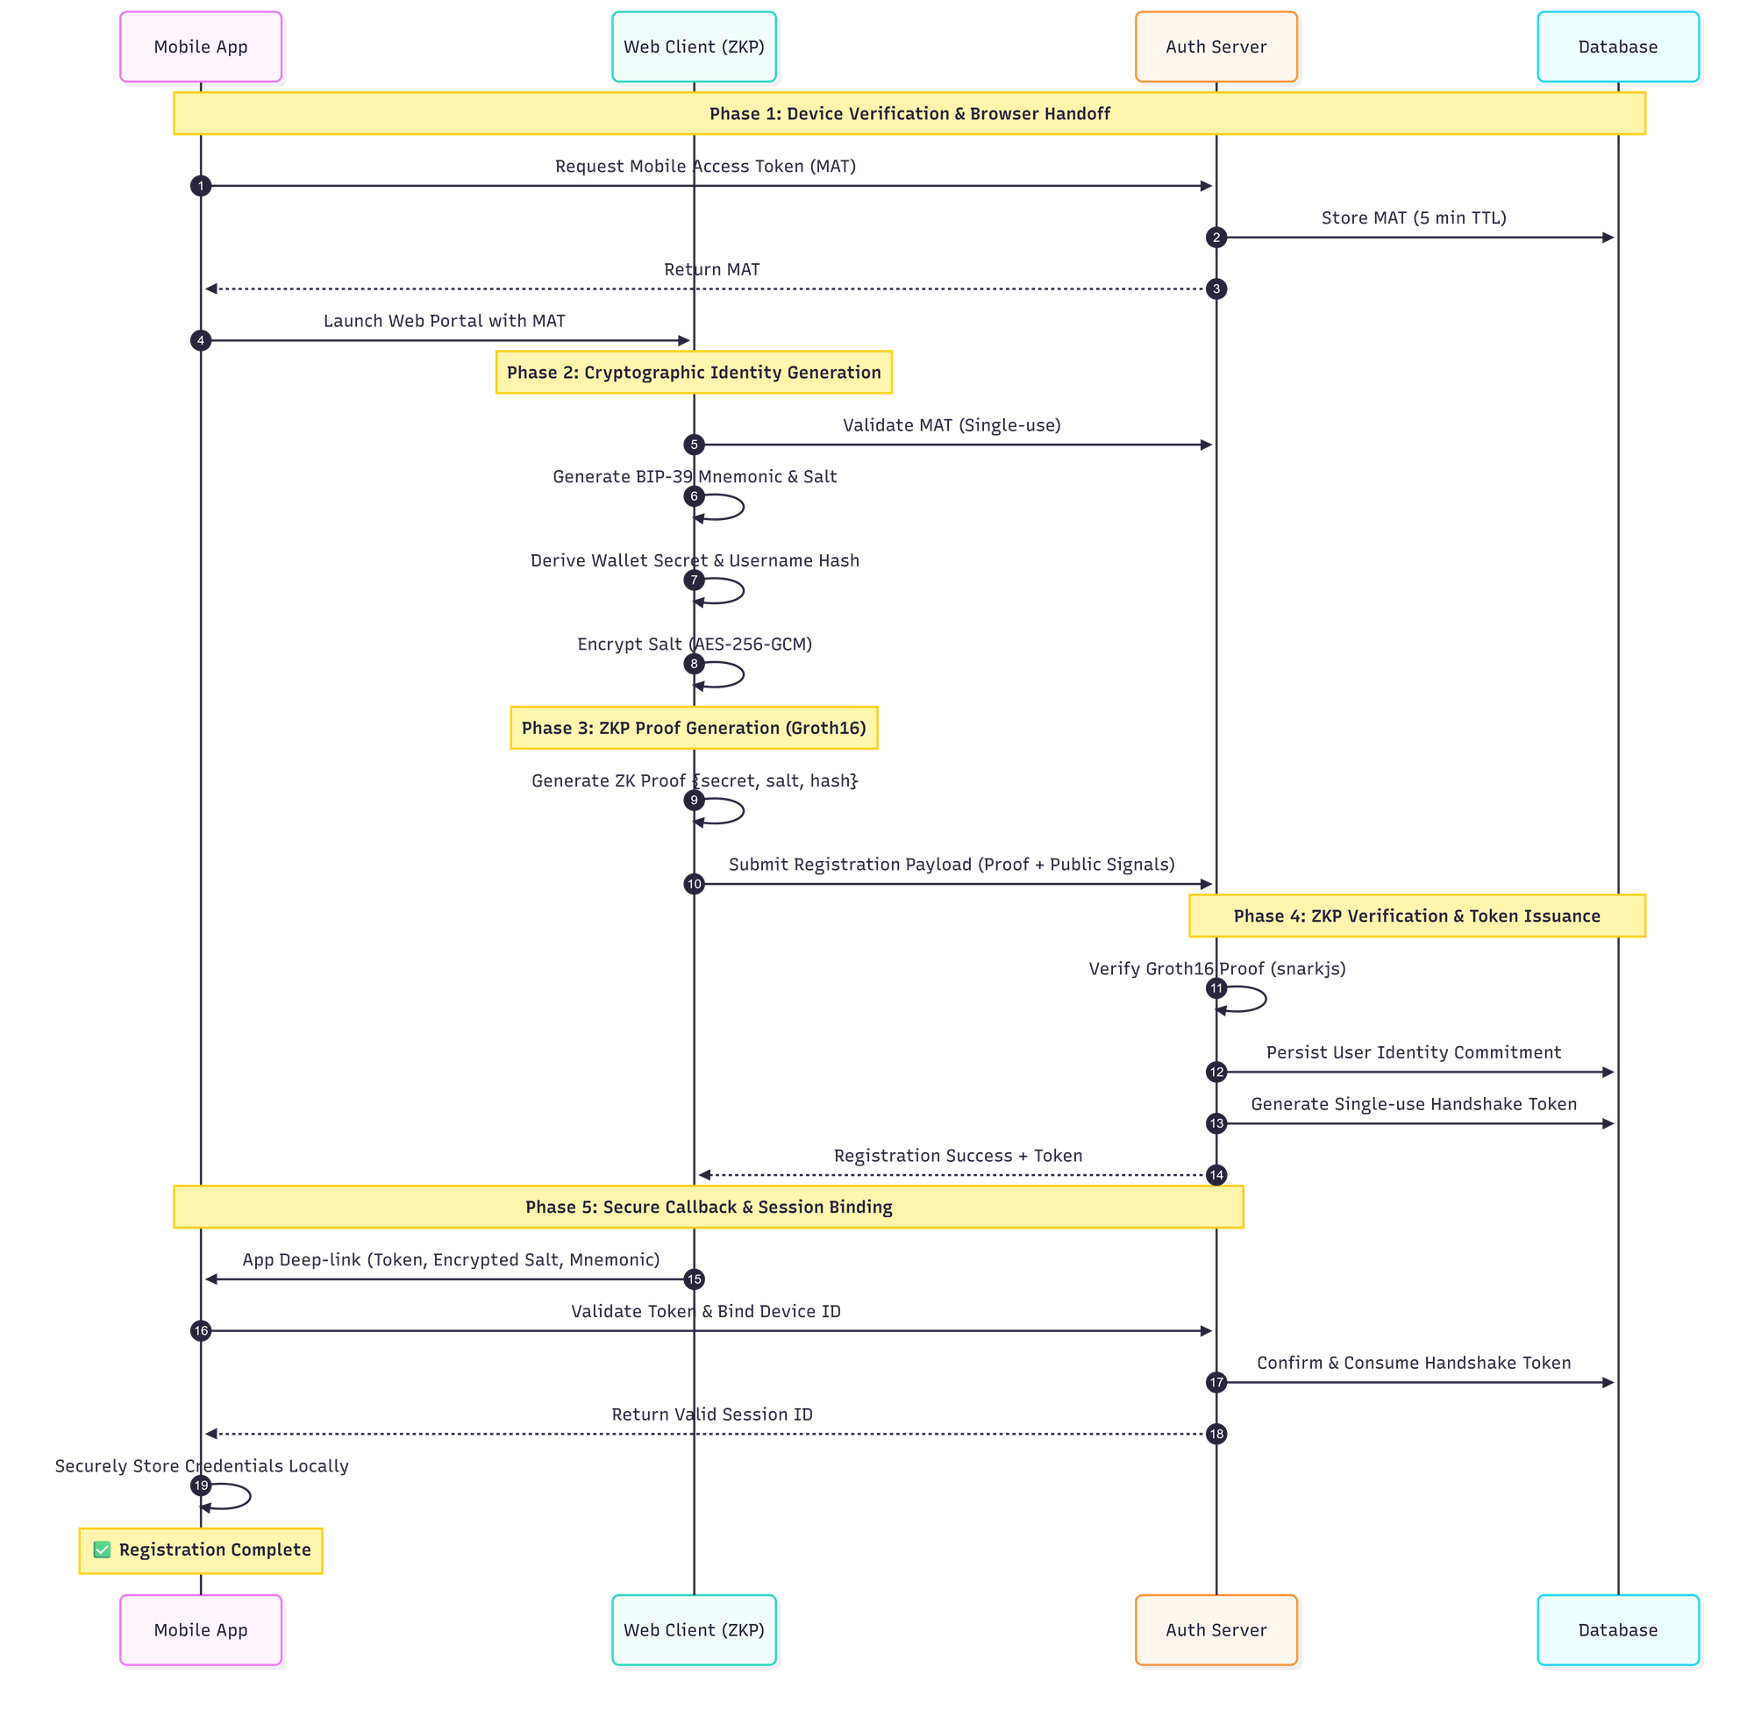
Figure 4.3: Zero-Knowledge Registration Flow
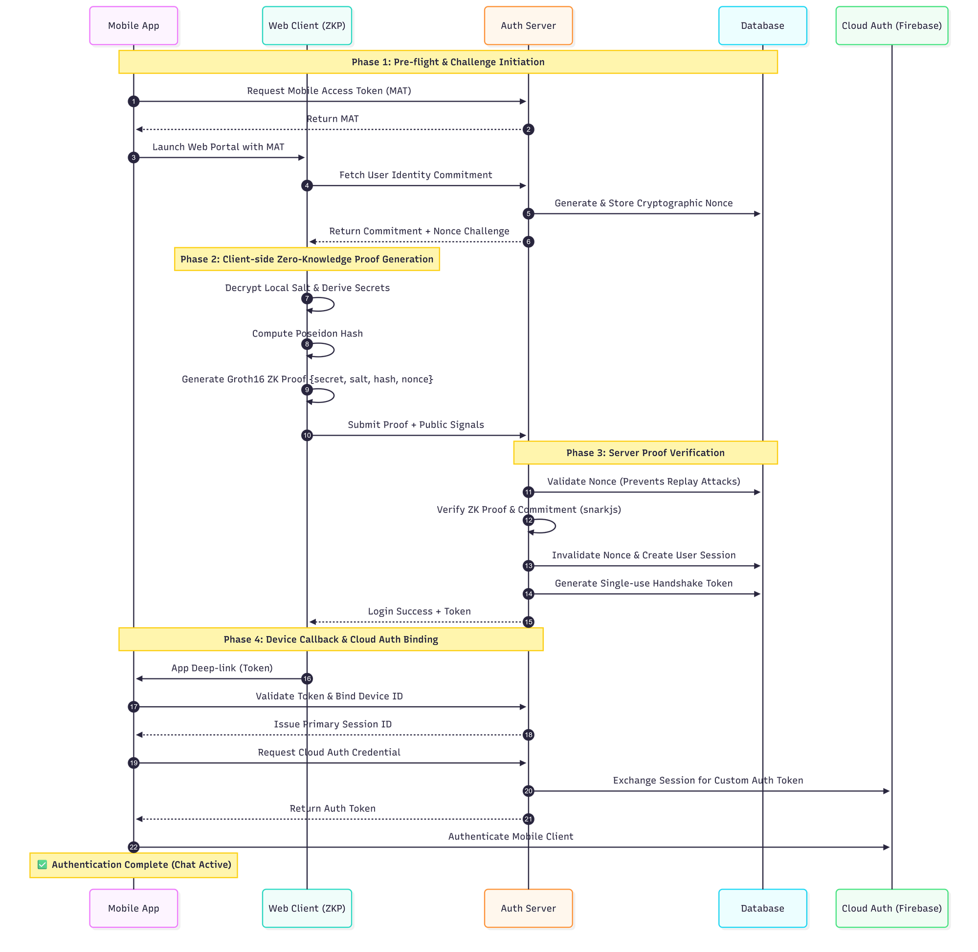
Figure 4.4: Zero-Knowledge Login Flow with Nonce-Bound Session
The cryptographic inputs are derived entirely on the client. The secret is derived from the user's wallet address using SHA3-256 and is never stored, being re-derived on each login. The salt is derived from a 24-word BIP-39 recovery phrase using HKDF-SHA256 and is stored on the device only as an AES-256-GCM envelope whose key is derived from the user's password using PBKDF2-HMAC-SHA256 with 310,000 iterations. The username hash is computed with SHA3-256 and reduced to a field element. Because the server receives only the Poseidon commitment and the proof, a breach of its database yields no passwords, secrets, or salts.
Replay protection is built into the login circuit. For each login attempt the server issues a fresh 64-bit nonce with a 60-second lifetime, and the circuit binds that nonce into the session output, so a captured proof cannot be replayed against a different nonce. On a successful login the nonce is consumed, a 30-minute session is created, and a single-use redirect token is issued. The session is bound to the device identifier and is rotated on every refresh to resist session-replay attacks.
4.5.2 Module B: End-to-End Encrypted Messaging
For message confidentiality the implementation adopts the Signal Protocol through the libsignal_protocol_dart library, rather than the bespoke Ed25519-and-AES scheme sketched in the proposal. This decision was made deliberately. Hand-rolled cryptographic protocols are notoriously error-prone, whereas the Signal Protocol is a peer-reviewed, widely deployed standard that provides forward secrecy and post-compromise security out of the box. Adopting it therefore strengthened the security guarantees of the system while reducing the risk of implementation flaws.
Under this protocol each device generates a long-term identity key pair, one signed pre-key, and one hundred one-time pre-keys, all on the Curve25519 elliptic curve. Only the public half of this bundle is published, to the user's Firestore document, so that other users can begin a session without any prior contact. When a message is sent, the application fetches the recipient's public bundle, establishes a shared secret using the Extended Triple Diffie-Hellman (X3DH) handshake, and encrypts the message with the Double Ratchet algorithm, which rotates the message key for every single message and thereby provides per-message forward secrecy. The resulting ciphertext is relayed through Firestore; the server never sees plaintext or private keys. The complete messaging flow is shown in Figure 4.5.
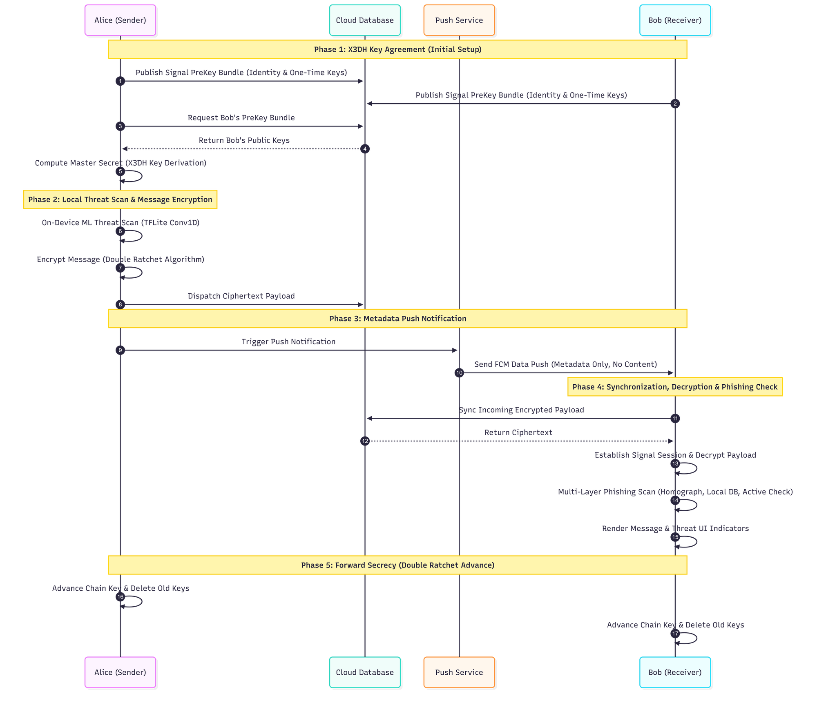
Figure 4.5: Signal Protocol End-to-End Encrypted Messaging
The application also implements an offline-first storage model. Incoming ciphertext is decrypted, written to a local Isar database, and then removed from Firestore, so that the device becomes the durable source of truth for conversation history and the cloud retains as little as possible. Audio and video calls use a separate WebRTC channel secured by DTLS-SRTP, with Firestore used only for call signalling. Account-recovery material is protected by the AES-256-GCM salt envelope described in the previous section.
4.5.3 Module C: On-Device AI Threat Detection
The threat-detection module analyses message content for social-engineering and phishing indicators entirely on the device, so that no message text is sent to a server for scoring. During development the unsupervised Isolation-Forest and Autoencoder approach named in the proposal was found to be poorly matched to the task, because a labelled corpus of safe and malicious messages was available and the problem is therefore naturally a supervised binary classification. The module was accordingly built around two supervised neural networks trained on the same dataset: a Bidirectional Long Short-Term Memory (Bi-LSTM) network used as a high-accuracy research model on the workstation, and a one-dimensional Convolutional Neural Network (Conv1D) used as the production model on the mobile device. The Conv1D model was chosen for deployment because every one of its operations is natively supported by TensorFlow Lite, which allows it to run on the phone's hardware accelerators without a compatibility delegate.
The model was trained on a balanced dataset of 5,740 labelled messages (2,890 safe and 2,850 threat) aggregated from the Enron corporate-email corpus, the ExAIS SMS spam collection, the Jigsaw multilingual toxic-comment dataset, and a set of hand-crafted synthetic insider-threat and phishing messages. Text is tokenised against a 10,000-word vocabulary and padded to a fixed length of 120 tokens. The production network consists of a 64-dimensional embedding layer, a 128-filter convolution with a kernel size of five, a global max-pooling layer, a 64-unit dense layer with dropout, and a single sigmoid output. It was trained with the Adam optimiser and binary cross-entropy loss, applying a balanced class weighting with an additional penalty on the threat class to discourage missed threats. After training, the model was converted to TensorFlow Lite with dynamic-range quantisation, producing a final artefact of approximately 681 KB. Table 4.8 summarises the production model.
Table 4.8: On-Device Threat-Detection Model
Property | Value
Task | Supervised binary text classification (safe / threat)
Architecture | Embedding(64) → Conv1D(128, k=5) → GlobalMaxPool → Dense(64) → Sigmoid
Vocabulary / sequence length | 10,000 words / 120 tokens
Training data | 5,740 labelled messages (2,890 safe, 2,850 threat)
Optimiser / loss | Adam / binary cross-entropy, threat-weighted
Deployed format / size | TensorFlow Lite, dynamic-range quantised, ~681 KB
Decision threshold | 0.65 (messages under 4 words are skipped)
On the device the model is loaded through the tflite_flutter interpreter, which first attempts to use the GPU and Android Neural Networks API for acceleration and validates the delegate with a self-test, falling back to the CPU if the accelerator behaves incorrectly. Each outgoing message is tokenised in the same way as during training and scored on a scale from zero to one. The score is attached to the message, and when it exceeds the 0.65 threshold the message is reported to a backend threat-log endpoint for administrator review. A red warning indicator is rendered on flagged messages on the receiving side. The complete on-device inference pipeline is shown in Figure 4.6. It is worth noting that, in the delivered build, the sender's scan is performed silently and does not block transmission; this behaviour is revisited in the evaluation in Chapter 5.
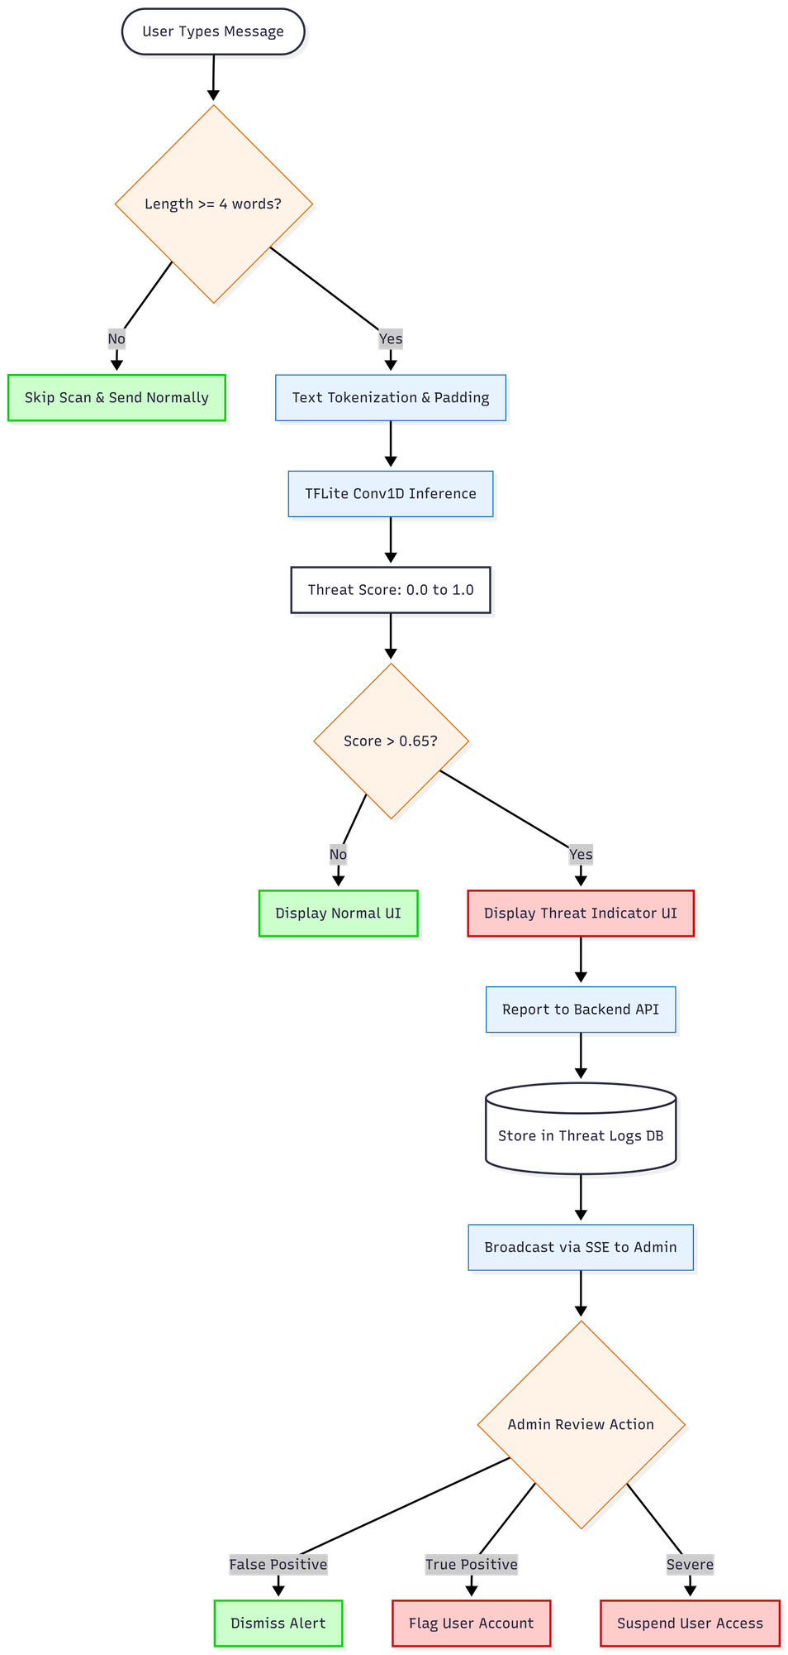
Figure 4.6: On-Device TensorFlow Lite Threat-Detection Pipeline
Message text is complemented by a dedicated, rule-based URL inspection layer that protects against malicious links. This layer combines a homograph detector that flags look-alike Unicode characters, a local database of known phishing domains matched by exact and near-miss comparison, a transport-security check, and an active lookup against the Google Safe Browsing API. Results are cached on the device for seven days, keyed by a hash of the content, to avoid repeated network calls. Dangerous and suspicious links trigger an interstitial warning dialog before the link can be opened. The URL-inspection architecture is shown in Figure 4.7.
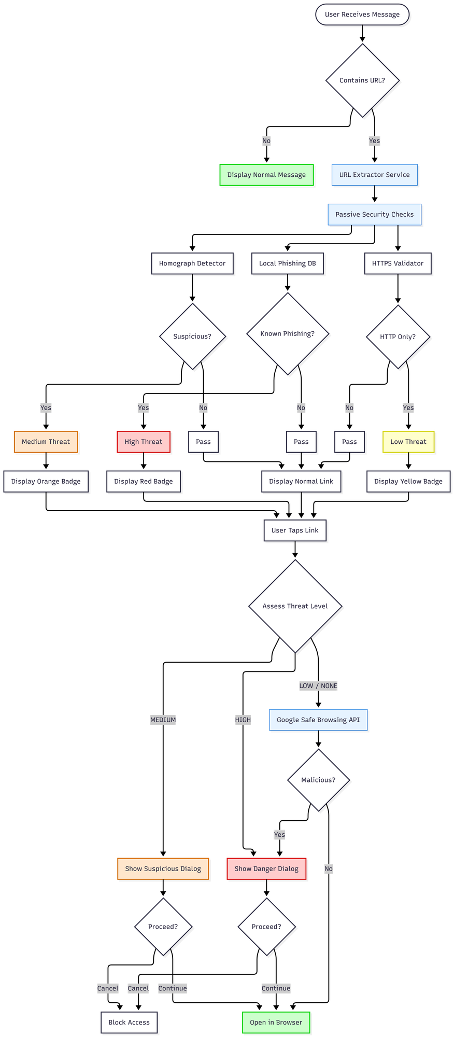
Figure 4.7: URL Phishing-Detection Architecture
4.6 User Interface and Experience Design
The mobile interface was designed so that strong security operates with minimal friction for non-technical staff. The application is built with Flutter and uses the provider package together with Flutter's native state mechanism; theming, including light, dark, and system modes, is the principal application-wide state. Navigation is screen-based and imperative. The main screens are the authentication landing screen, the profile-setup screen, the conversation list, the chat screen, the call screen, and the settings screen.
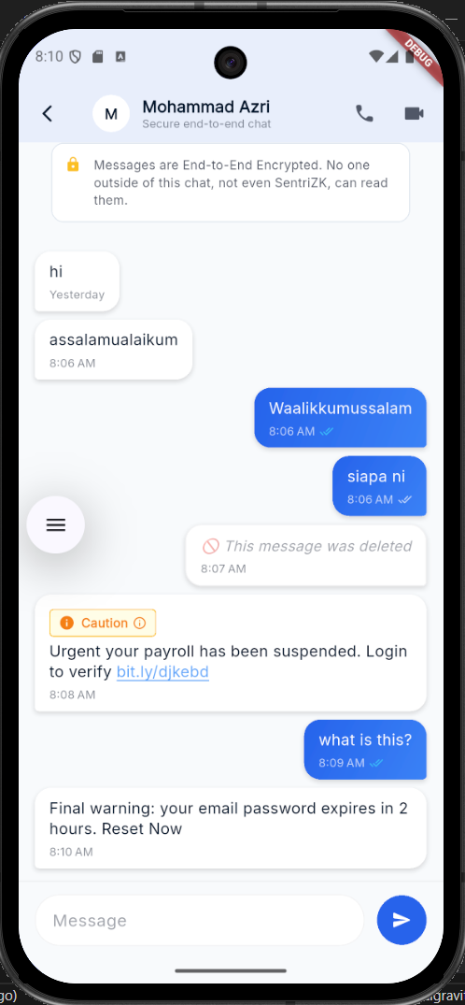
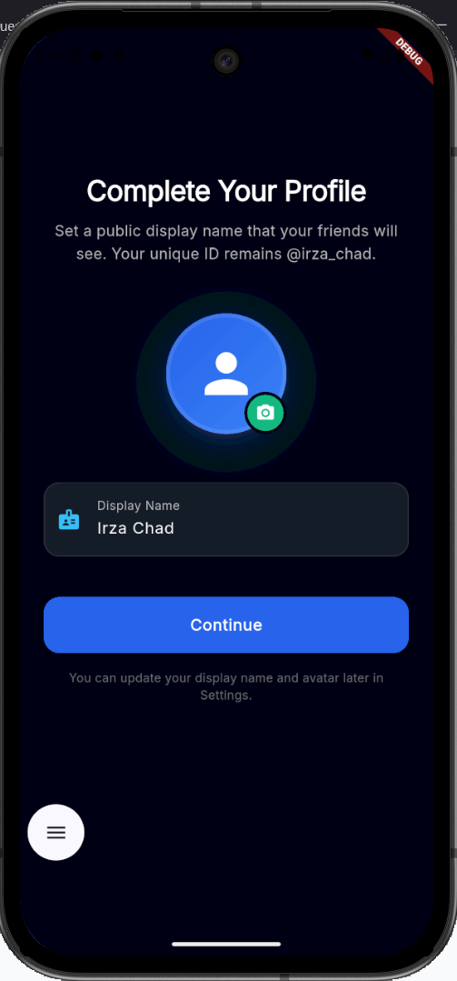
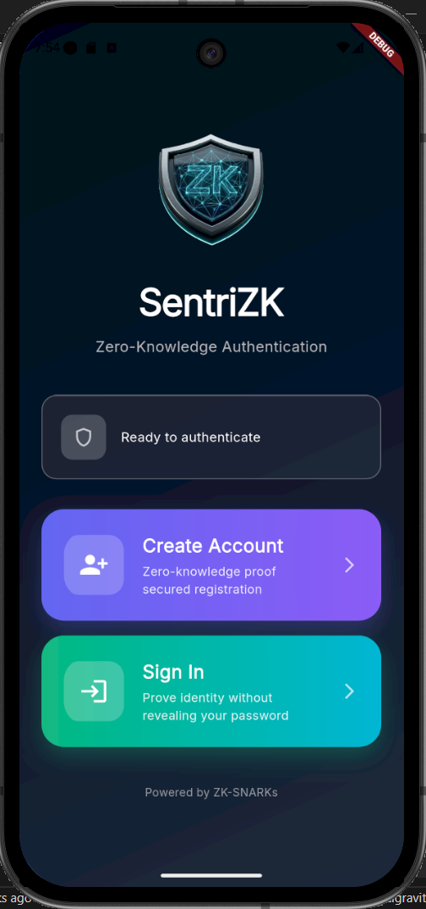
Security feedback is surfaced directly in the conversation. A received message that the on-device model scores above the threat threshold is annotated with a tinted warning badge reading “Suspicious message detected”, while links are classified into four levels — none, low, medium, and high — and rendered with colour-coded badges, with dangerous and suspicious links additionally guarded by a confirmation dialog. Representative screenshots of the running application are shown in Figure 4.8.

Figure 4.8: Mobile Application User Interface (representative screens)
The web portal presents two faces. For end users it is a focused, single-purpose cryptographic surface for registration, login, and account recovery, gated by the Mobile Access Token so that it cannot be used outside the intended flow. For the organisation it also hosts an administrator panel, built on the same Next.js application, that lists users, displays flagged threats in real time through a server-sent event stream, and allows an administrator to hold or revoke an account. The administrator panel is shown in Figure 4.9.
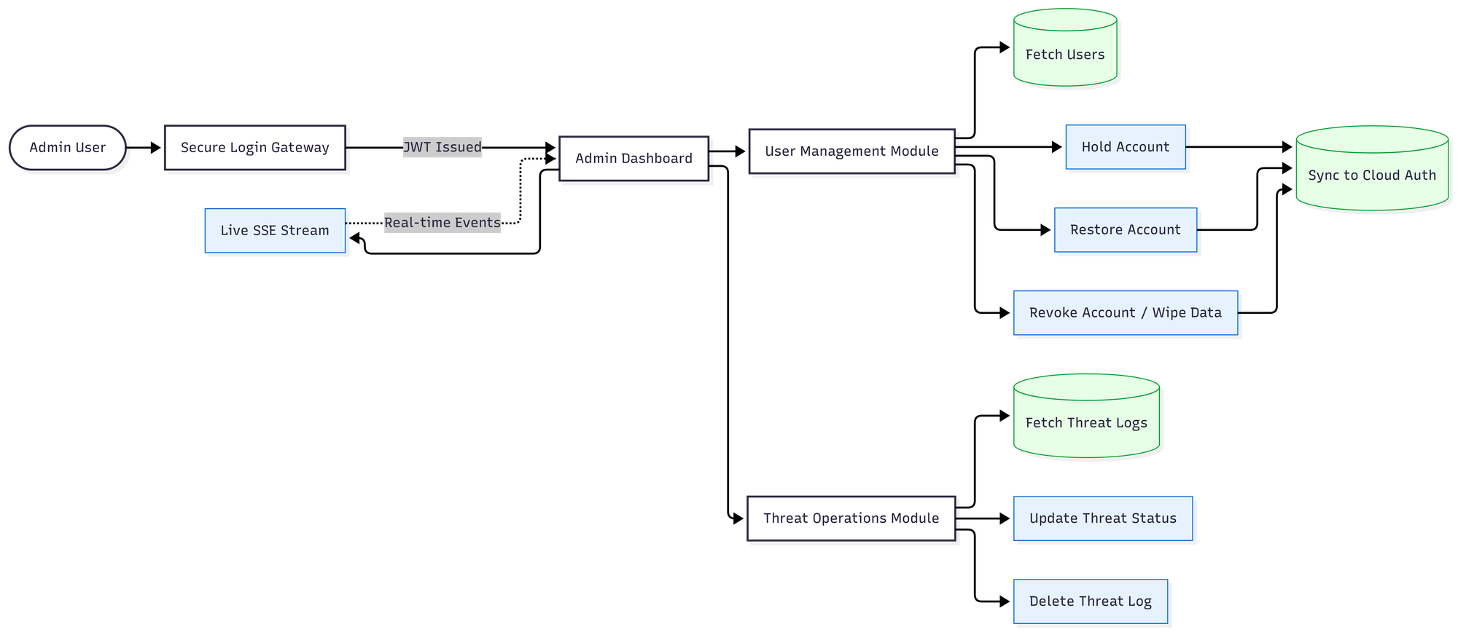
Figure 4.9: Web-Based Administrator Panel
4.7 System Integration
Integrating four heterogeneous tiers into a single coherent product was a central engineering challenge. The most important integration point is the Mobile Access Token bridge between the mobile application and the web portal. The application launches the browser with a single-use token, the browser performs the cryptographic work and returns the result through a strictly validated sentriapp:// deep link, and the application verifies the scheme, suppresses duplicate callbacks, and exchanges the redirect token for a device-bound session. The relevant Android intent filters are declared so that the operating system routes the callback back into the application.
The remaining integration points follow conventional patterns. The mobile application and web portal both communicate with the backend over REST. After a successful zero-knowledge login, the backend issues a Firebase custom token that allows the client to authenticate to Firestore, bridging the password-less identity into the real-time messaging tier. Message delivery itself is decoupled from the backend: clients write ciphertext directly to Firestore, and the sender then calls a backend notify endpoint that sends a metadata-only push notification through Firebase Cloud Messaging so that the recipient's device wakes and decrypts the message locally. The session lifecycle that underpins all of these interactions — issuance, validation, refresh, and revocation — is shown in Figure 4.10.
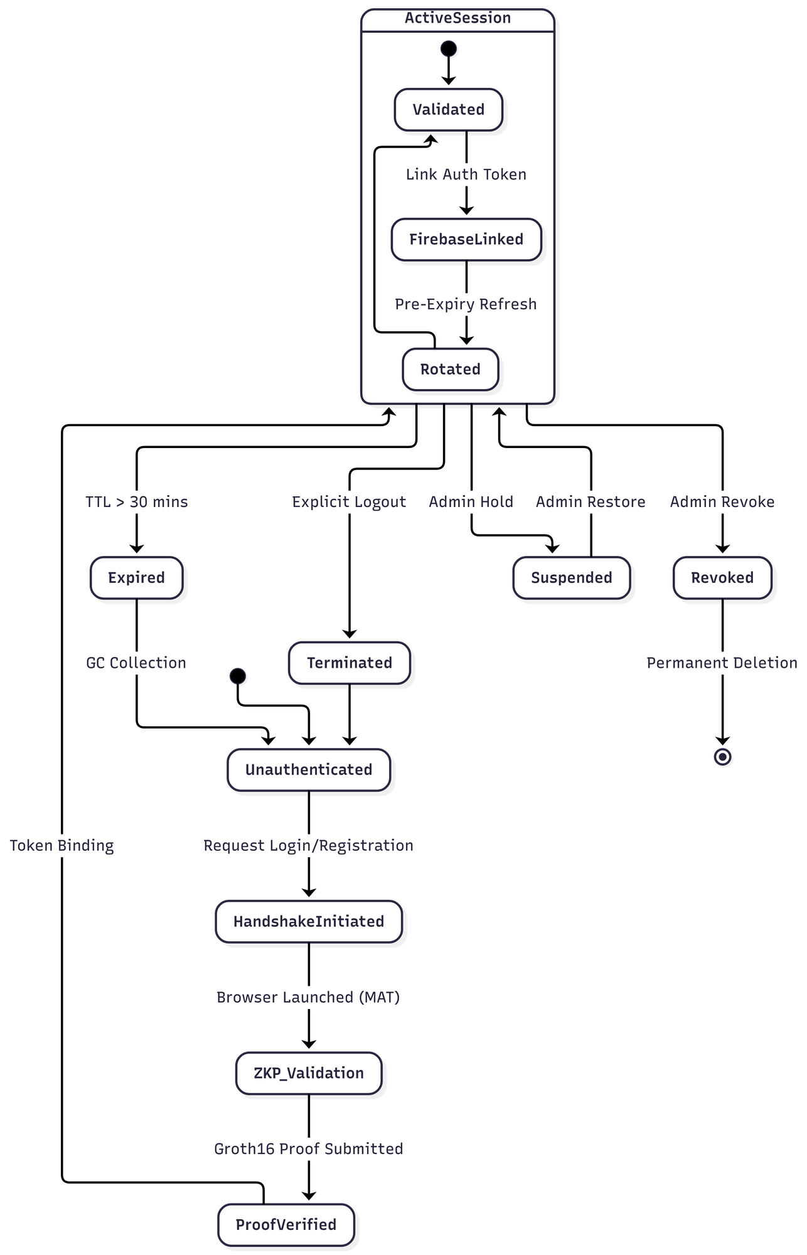
Figure 4.10: Session Lifecycle and Security
4.8 Source-Code Management and Version Evolution
The project was maintained as a single Git monorepository on GitHub, organised into top-level directories for the backend, the web and mobile front-ends, the machine-learning pipeline, the documentation, and the testing harness. Development followed a feature-branch workflow, in which roughly thirty branches — for end-to-end messaging, audio and video calling, the administrator panel, the machine-learning model, notifications, the user interface, and security hardening — were merged into the main branch over approximately 296 commits across a seven-month period.
Consistent with the Rapid Application Development methodology, the system was delivered in successive increments rather than as a single release, and the prototype was versioned continuously. The first increment established the core platform: zero-knowledge registration and login, the Signal Protocol messaging core, and the initial mobile interface. The second increment added the intelligence and communication features and hardened the platform: the on-device threat-detection model, the URL-inspection layer, audio and video calling, the administrator panel, and the migration of the backend from an early file-based store to the Supabase PostgreSQL database. These increments are reflected in the version history summarised in Table 4.9.
Table 4.9: Iterative Version Evolution of the Prototype
Increment / Release | Focus | Representative changes
v1.0.1 (Increment 1) | Core platform | ZKP auth, Signal messaging, base UI
v1.0.5+6 | Stabilisation | Bug fixes, Supabase migration
v1.0.6+7 (Increment 2) | Intelligence | On-device ML model, threat logging
v1.0.8+9 | Hardening | Calling, admin panel, recovery, fixes
4.9 Deployment Environment
The deployment strategy reflects the project's goal of providing enterprise-grade security to small and medium enterprises at minimal cost, and therefore favours self-hosting and free service tiers over recurring cloud charges. During development the backend was run locally on port 6000 and exposed to physical test devices through an ngrok tunnel, which avoids the security risk of router port-forwarding. For production the components are reached through a custom domain, with the backend served from backend.sentrizk.me and the web portal from frontend.sentrizk.me; the backend is intended to run under a process manager behind a TLS reverse proxy, and the web portal can be served either from the same self-hosted node or from a managed platform. The two managed services used by the system, Supabase and Firebase, both operate within their free tiers, so the only recurring cost is the domain registration. The deployment topology is shown in Figure 4.11.
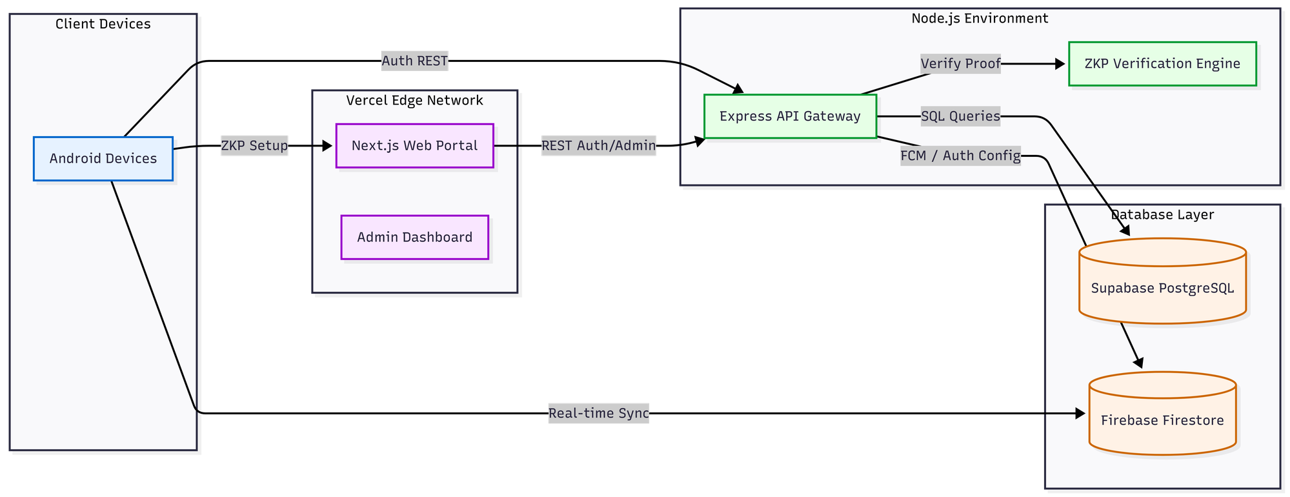
Figure 4.11: Deployment and Infrastructure Architecture
Persistence in production is divided between the two services according to their strengths. Supabase PostgreSQL holds the authentication state in five tables users and their commitments, sessions, single-use tokens, mobile access tokens, and the threat log while Firebase provides the real-time message relay, the custom-token authentication bridge, and push notifications. This separation keeps the security-critical authentication data in a relational store under the project's control, while delegating high-volume real-time delivery to a managed platform.
4.10 Chapter Summary
This chapter has documented the development of the SentriZK system, from its environment and dependencies through to its deployment. It described the polyglot architecture of four cooperating tiers and the configuration required to build each one. It then detailed the implementation of the three core security modules: zero-knowledge authentication using Circom circuits and a Mobile Access Token bridge, end-to-end encrypted messaging using the Signal Protocol, and on-device threat detection using a quantised convolutional neural network supported by a rule-based URL-inspection layer. The user-interface design, the integration of the tiers, the source-code management, and the deployment environment were then presented. Several implementation choices that evolved beyond the original proposal — the adoption of the Signal Protocol, the use of a supervised convolutional model in place of an unsupervised anomaly detector, the web-assisted proof generation, and the choice of the Isar database and the provider state-management package were identified and justified as informed engineering decisions that improved the security or feasibility of the delivered system. With the system now built, the next chapter, Chapter 5, presents the testing performed on the prototype and discusses the results against the project's objectives.

